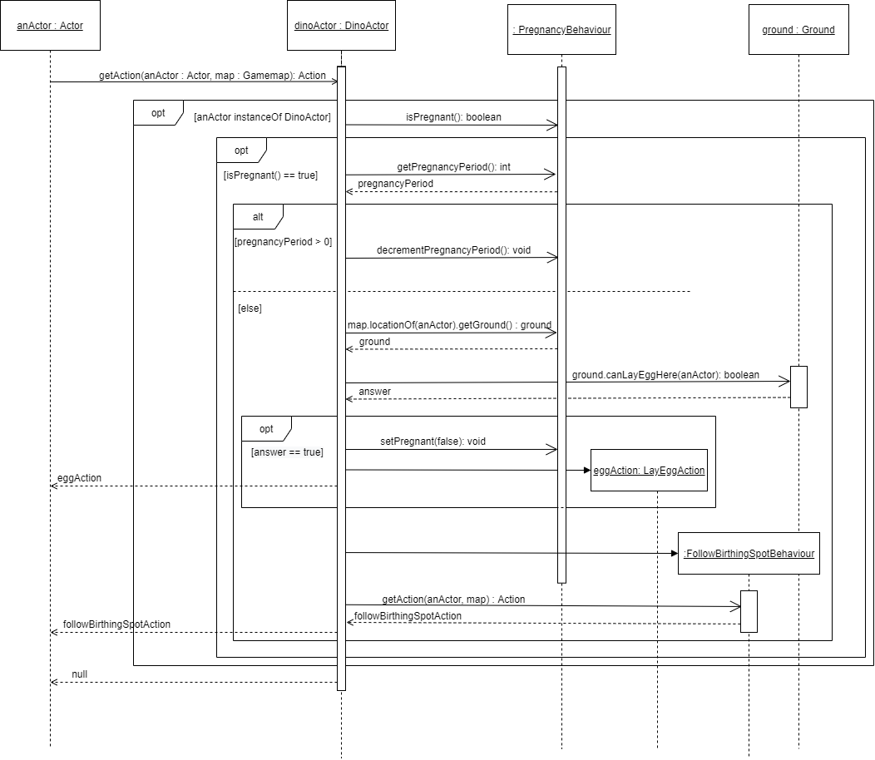**Sequence diagram – PregnancyBehaviour.getAction**

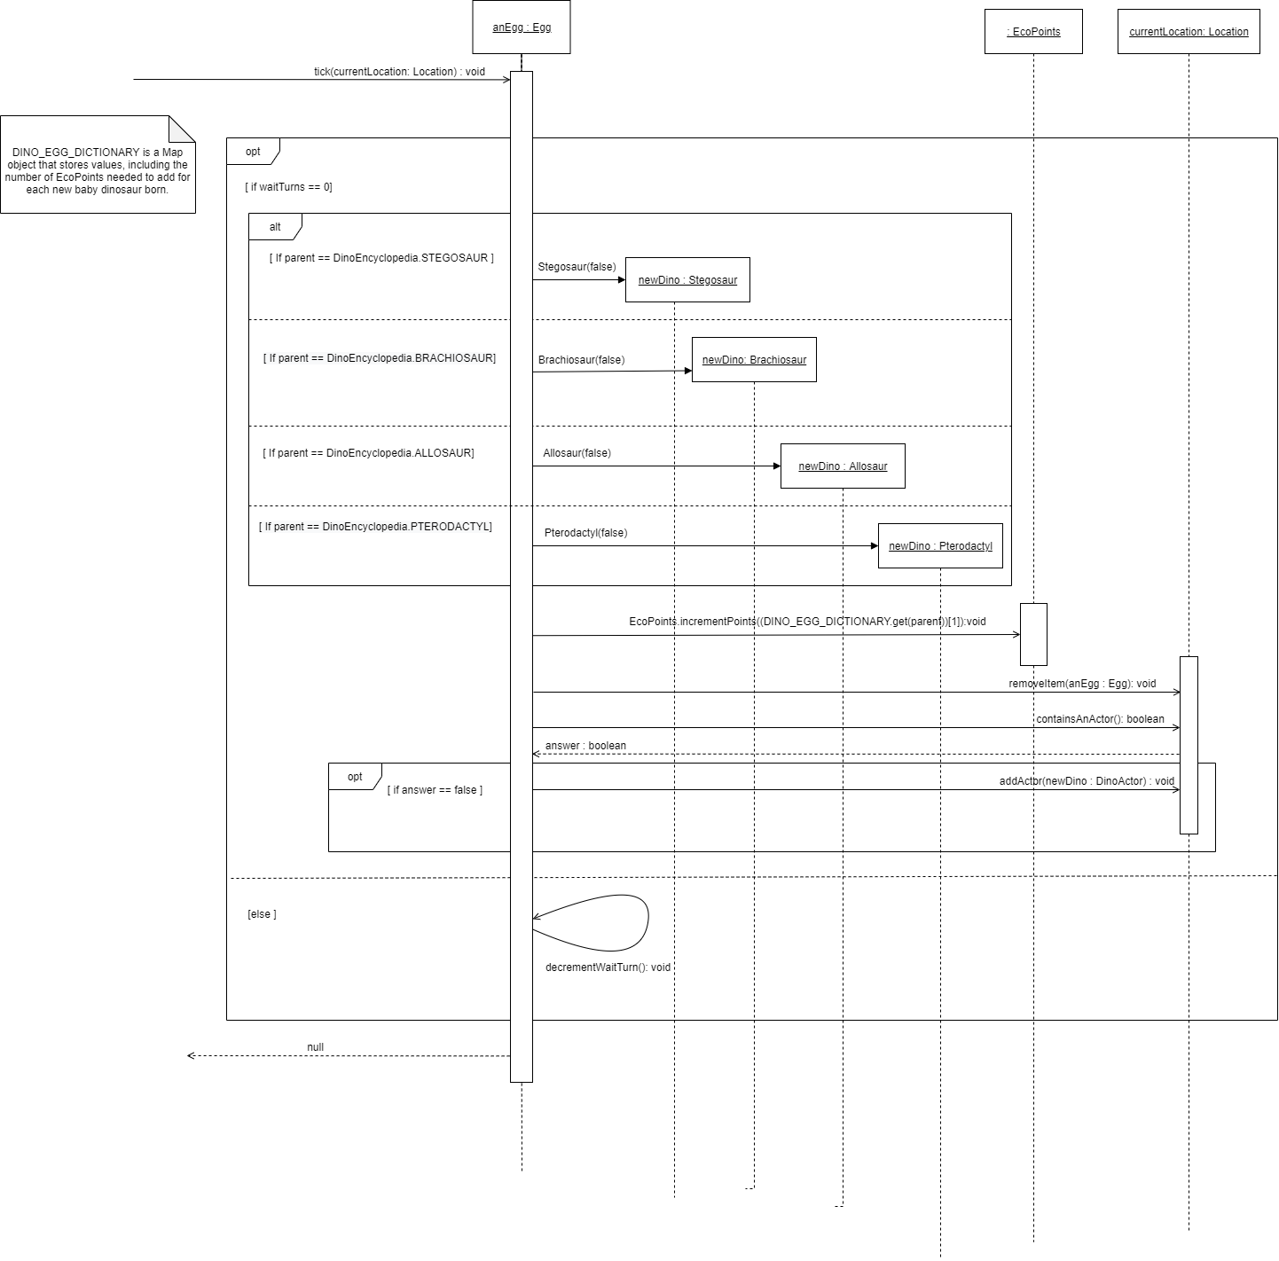**Sequence diagram – Egg’s tick method**

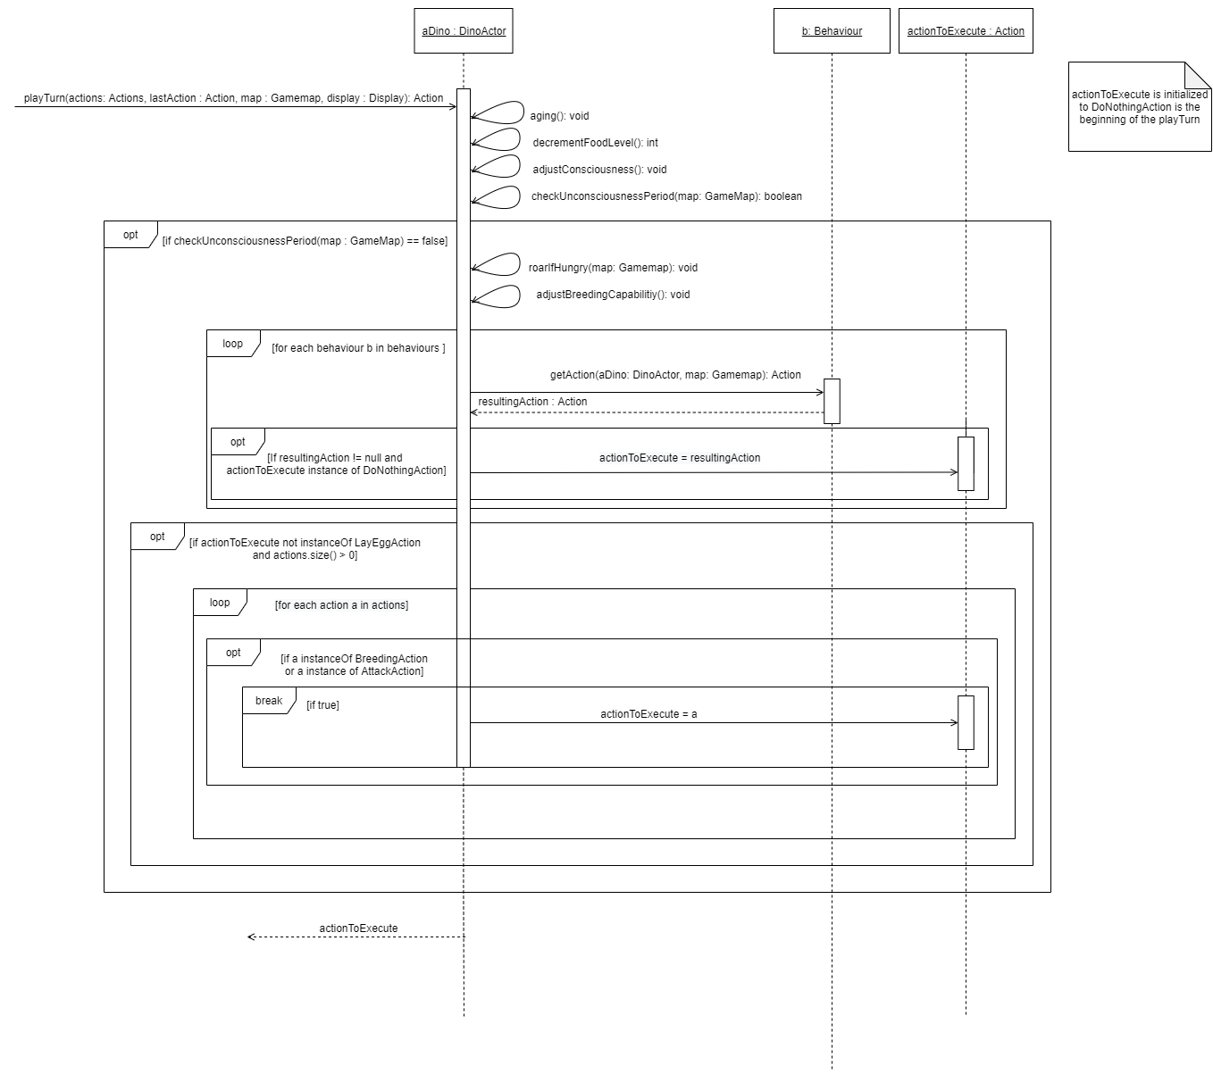**Sequence diagram – DinoActor’s playTurn method**

**Sequence diagram – PlayerFeedAction’s execute method**

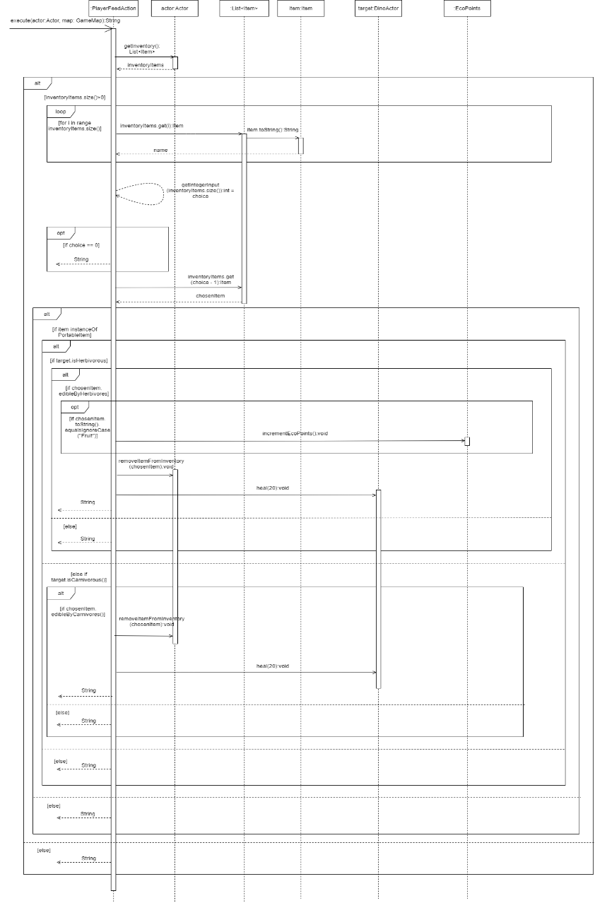

**Sequence diagram – SearchItemAction’s execute method**

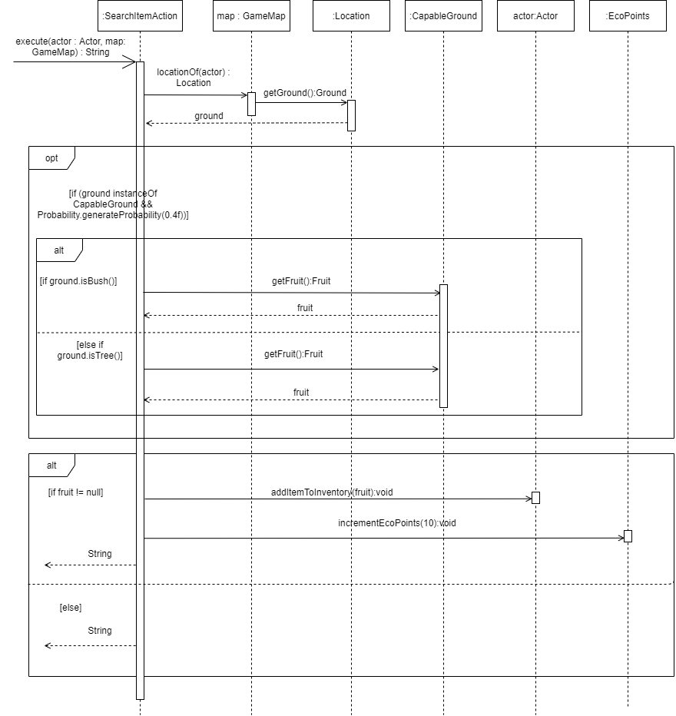

**Sequence diagram – VendingMachine’s choose method**

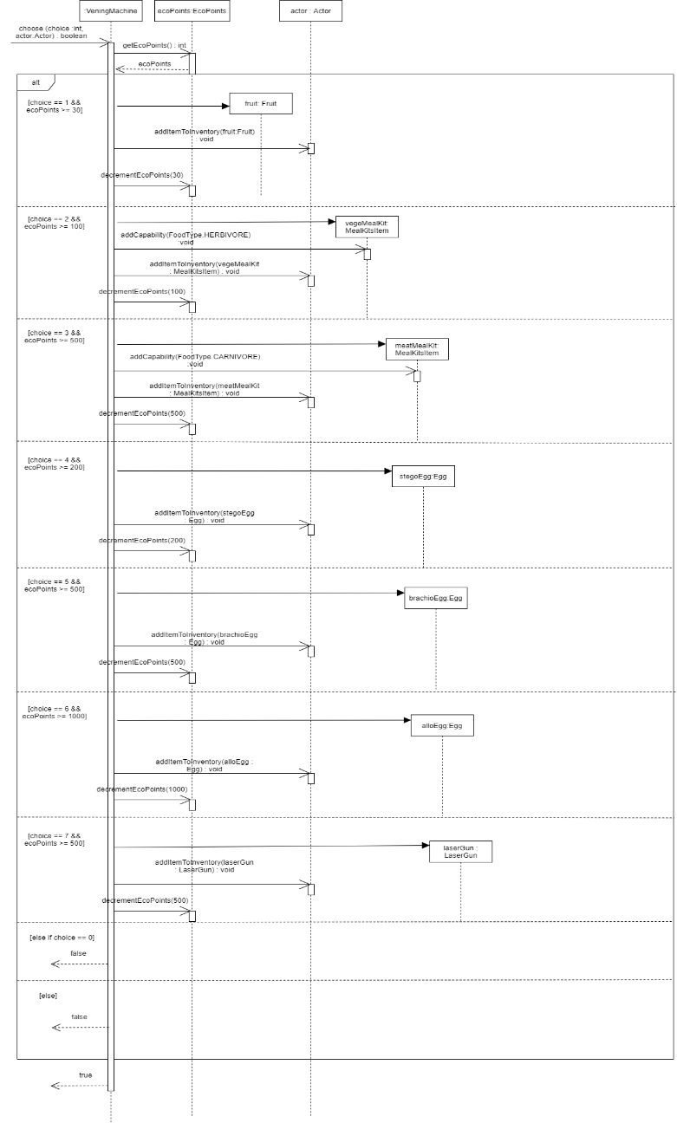

**Sequence diagram – AttackBehaviour’s getAction method**

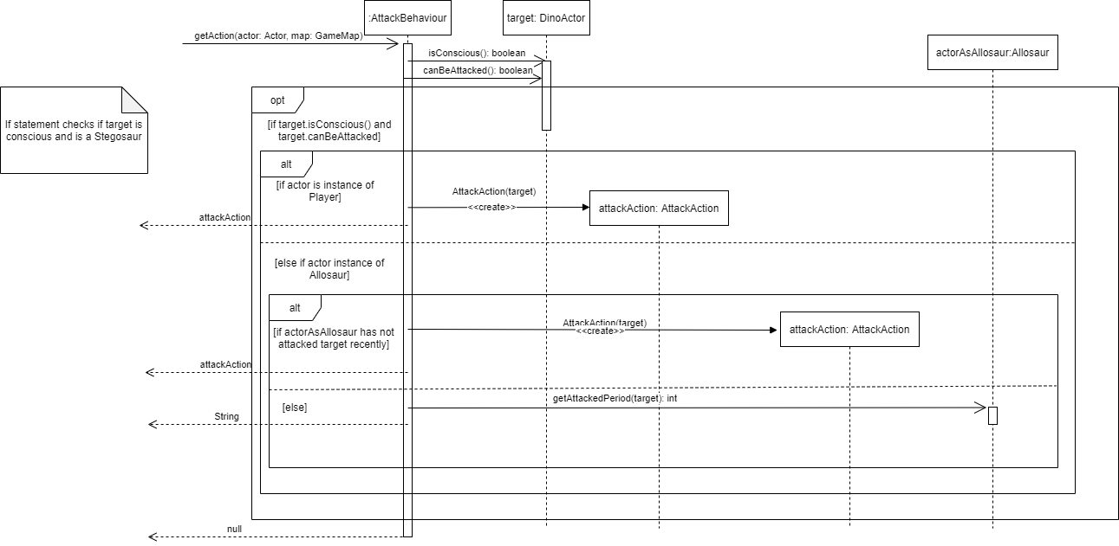

**Sequence diagram –AttackAction’s execute method**

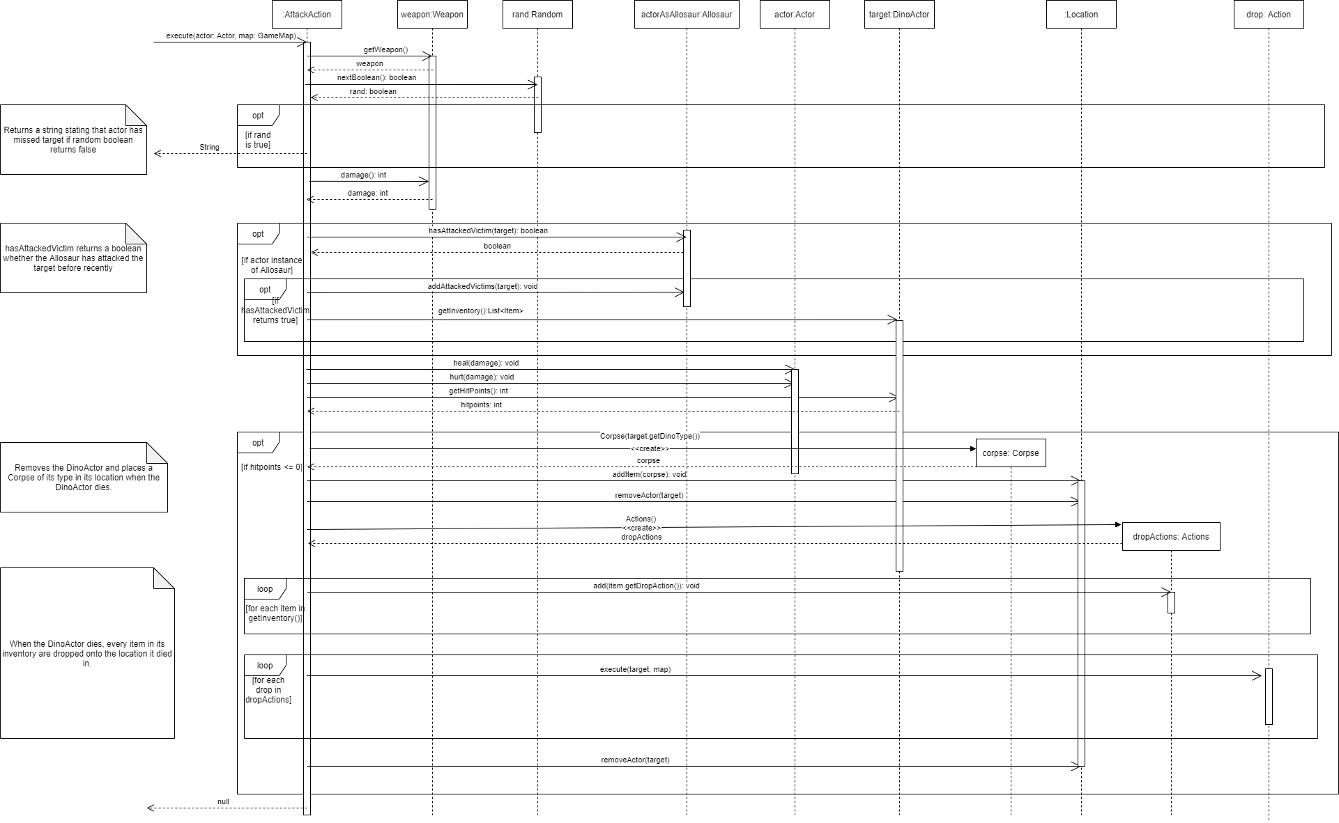

**Sequence diagram – FeedingBehaviour’s getAction method**

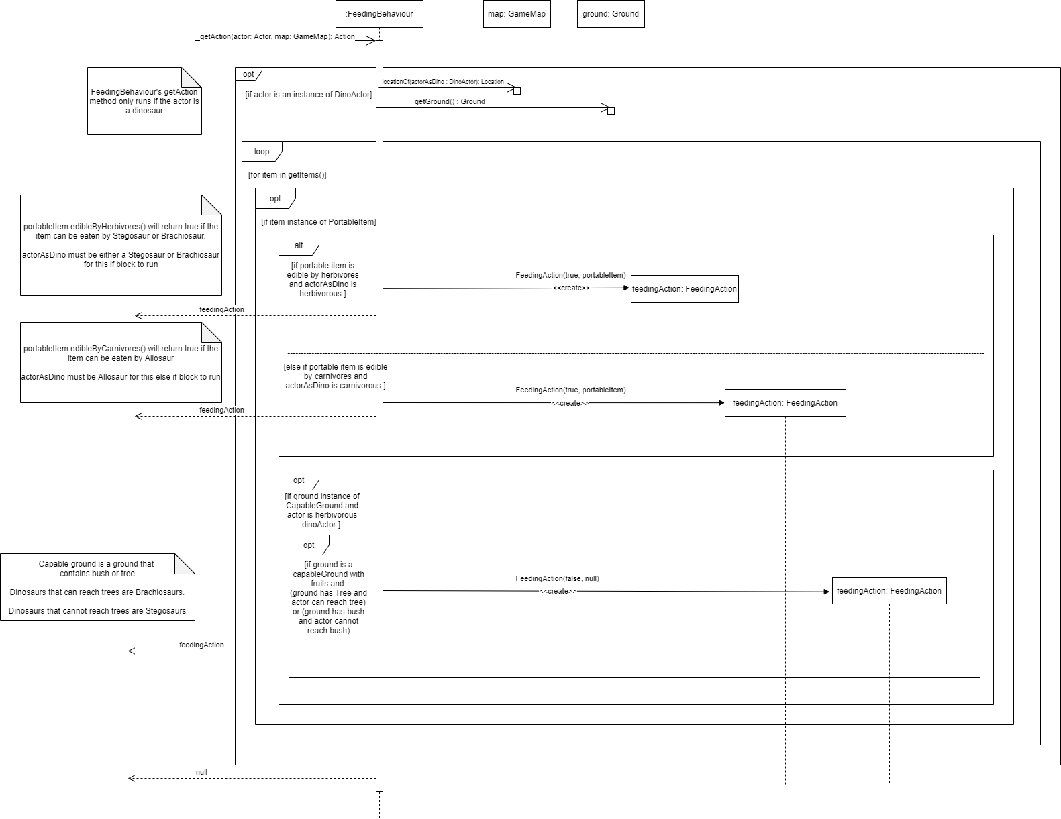

**Sequence Diagram – FeedingAction’s execute method**

